

**Green University of Bangladesh**

**Department of Computer Science and Engineering (CSE)**

**Semester: (Spring, Year:2024), B.Sc. in CSE (Day)**

**Lab Report NO #02**

**Course Title: Operating System Lab**

**Course Code: CSE 310 Section: 221 D6**

**Lab Experiment Name: Shell Scripting-2.**

**Student Details**

| **Name** | | **ID** |
| --- | --- | --- |
| **1.** | Tanvir Ahmed | 221002461 |

**Lab Date : 18/3/2024**

**Submission Date : 25/3/2024**

**Course Teacher’s Name : Jarin Tasnim Tonvi**

| **Lab Report Status**  **Marks: ………………………………… Signature:.....................**  **Comments:.............................................. Date:..............................** |
| --- |

**1. TITLE OF THE LAB REPORT EXPERIMENT**

Shell Scripting - II

**2. OBJECTIVES/AIM**

**The main objective of this lab report is to learn functionalities of the shell programming. Such as,**

* Implementation of loop in shell (while loop and for loop)
* Problem solve using function
* Use of array

I am solving two problems using these functionalities which I learned from our previous lab class.

1. Find the frequency of an array using a while loop.
2. Find the 2nd and 3rd highest numbers form an array and sum of them.

**3. PROCEDURE**

**For 1st problem:**

1. At first, creating a file using this command, touch freq.sh
2. Checking details of all files using this command, ls -l
3. Now we don’t have access to executing this file so we giving access using this command, chmod+x freq.sh
4. Now we write the program on the freq.sh file.
5. Taking a number from the user.
6. Declare 10 variables for the frequency
7. Now run a while loop and update the increment the variables if there is any corresponding number present.
8. At last, print all variables if the variable is not zero.

**For 2nd problem:**

1. Firstly create a file using the command, touch sm.sh
2. Giving it access for the execution using the command, chmod +x sm.sh
3. Now write the program on the sm.sh file
4. In the program first, take a number from the user, that is how many numbers the user will provide.
5. Now call a function named highest in which we find the 1st, 2nd and 3rd highest number.
6. From the highest function, I called another function named sum, to sum and print the 2nd and 3rd highest number.

**4. IMPLEMENTATION**

**For 1st problem:**

Source Code:

#!/bin/bash

read -p "Enter the number: " k

n1=0

n2=0

n3=0

n4=0

n5=0

n6=0

n7=0

n8=0

n9=0

n0=0

i=0

while [ $i -lt ${#k[0]} ]

do

if [ ${k:i:1} == 1 ]

then

n1=$(( n1+1 ))

fi

if [ ${k:i:1} == 2 ]

then

n2=$(( n2+1 ))

fi

if [ ${k:i:1} == 3 ]

then

n3=$(( n3+1 ))

fi

if [ ${k:i:1} == 4 ]

then

n4=$(( n4+1 ))

fi

if [ ${k:i:1} == 5 ]

then

n5=$(( n5+1 ))

fi

if [ ${k:i:1} == 6 ]

then

n6=$(( n6+1 ))

fi

if [ ${k:i:1} == 7 ]

then

n7=$(( n7+1 ))

fi

if [ ${k:i:1} == 8 ]

then

n8=$(( n8+1 ))

fi

if [ ${k:i:1} == 9 ]

then

n9=$(( n9+1 ))

fi

if [ ${k:i:1} == 0 ]

then

n0=$(( n0+1 ))

fi

i=$(( i+1 ))

done

if [ $n0 != 0 ]

then

echo "0 = $n0 times"

fi

if [ $n1 != 0 ]

then

echo "1 = $n1 times"

fi

if [ $n2 != 0 ]

then

echo "2 = $n2 times"

fi

if [ $n3 != 0 ]

then

echo "3 = $n3 times"

fi

if [ $n4 != 0 ]

then

echo "4 = $n4 times"

fi

if [ $n5 != 0 ]

then

echo "5 = $n5 times"

fi

if [ $n6 != 0 ]

then

echo "6 = $n6 times"

fi

if [ $n7 != 0 ]

then

echo "7 = $n7 times"

fi

if [ $n8 != 0 ]

then

echo "8 = $n8 times"

fi

if [ $n9 != 0 ]

then

echo "9 = $n9 times"

fi

**For 2nd problem:**

#!/bin/bash

highest()

{

x=0

y=0

z=0

i=1

while [ $i -le $1 ]

do

read -p "Enter the number: " k

if [ $k -ge $x ]

then

z=$y

y=$x

x=$k

elif [ $k -ge $y ]

then

z=$y

x=$k

elif [ $k -ge $z ]

then

z=$k

fi

i=$(( i+1 ))

done

sum $x $y $z

}

sum()

{

s=$(( $2+$3 ))

echo "The sum of second and third highest number is: ($2+$3) = $s"

}

read -p "Enter the number of elements: " n

highest $n

#echo "$x $y $z"

**5. TEST RESULT / OUTPUT**

**For 1st problem:**

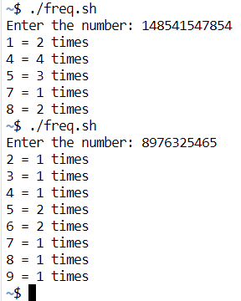

fig1. Here is the printed frequency for every number present in the input numbers.

**For 2nd problem:**

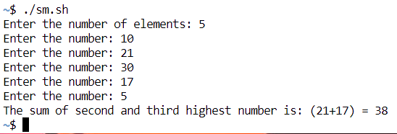

fig2. Here is the output of the second problem which is the sum of 2nd and 3rd highest numbers from some given numbers.

**6. ANALYSIS AND DISCUSSION**

**For 1st problem:**

* In this exercise, I am calculating the frequency of every number present in the given number.
* I implemented the functionalities that I learned from the previous class. Here especially while loop and arry.
* I tried to solve this problem more efficiently but I failed. Because I have not learned that much functionality to solve the problem more efficiently.
* I use googled how to access individual information from the input number.
* After spending a long time on this problem finally, the program is working efficiently.

**For 2nd problem:**

* In this exercise, I find 2nd and 3rd highest numbers from input.
* Here I use function and while loop that I learned from my previous lab classes.
* I did not need any help from the internet while solving this problem.

**7. SUMMARY**

This lab exercise demonstrates the successful implementation of required problems using the functionality of shell programming which I learned from the previous class. I implemented two exercises properly with the shell programming that I learned from the previous class. In the first problem, I faced some difficulty, and what I solved was not an efficient way to solve that problem. In the second problem, I solved the problem without any difficulties, yes I faced some syntax errors and I fixed those problems without any problems.